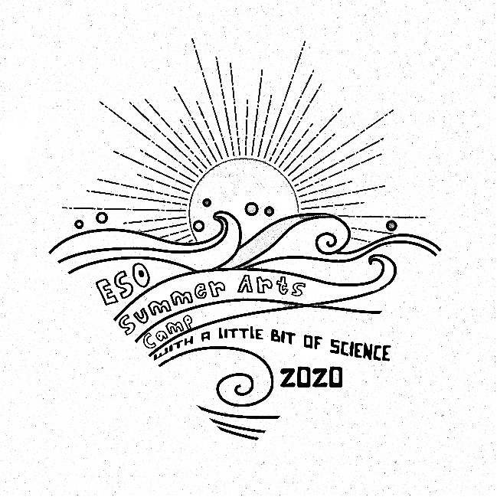

ESO Summer Arts Camp
(with a little bit of Science)
July 22-26 and August 5-9, 2020

ESO Summer Camp features classes in visual and performing arts as well as science and horticulture. Campers aged 4-11 will experience the fun of visual and performing arts and science, learning from guest authors and instructors from the Eastern Shore of Virginia. The last day of each camp week will feature an open house for parents and friends to see all the fun had during camp. Camp is divided into 3 age groups based on age.
Drop off between 8:45 -9 AM
Check in with ESO Office, camper marked present, hangs lunch bag and joins Age group.
Pick up between 3:15-3:30PM
Check out with ESO Office staff. Campers will be dismissed after their last class.
What to Bring (labeled with Child’s Name):
- Packed Lunch
- Water Bottle
- A change of clothes
- Sunscreen and bug spray
- Any daily medication

Cost:
$150/per week or $275 for 2 weeks
- $50 deposit required at the time of registration

$15 registration fee; valid for all classes July 2019-June 2020
Scholarships up to 50% of tuition
$10 Sibling Discount

A 3.5% processing fee will be applied to all online and credit card payments

